R A D I C A L

The Bottom Line:
___________Times Demand
__________ Faith

2 Timothy 3:1 (NKJV)
1 But know this, that in the last days perilous times will come:

Get In The F.L.O.W.

1. F: _________ Jesus

Matthew 10:38(NLT)
If you refuse to take up your cross and follow me,
you are not worthy of being mine.

The commitment to follow Jesus is very simple in __________, but it takes great humility, courage and _______________ to realize.

2. L: _______ Your Vision

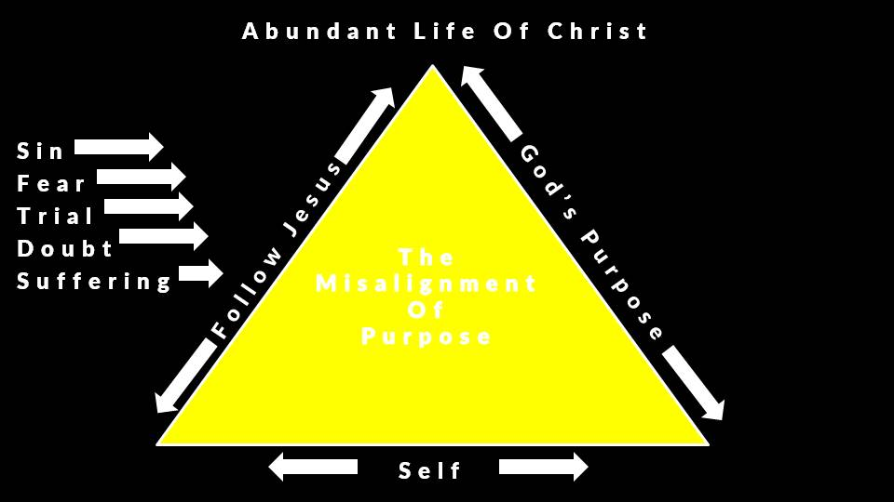
3. O: ______ Your Inability

We can never follow Jesus by means of our own intellect, wisdom and __________.

Through the ________ Jesus did what we could never do in order to transform us into what we could never be.

4. _______ With Determination

1 Peter 2:21 (NLT)
21 For God called you to do good, even if it means suffering, just as Christ suffered for you. He is your example,
and you must follow in his steps.

Notes:
______________________________________________________________________________________________________________________________________________________________________________________________________________________________________________________________________________________________________________________________________________________________________________________________________________________________________________________________________________________________________________________________________________________________________________________________________________________________________________________________________________________________________________________________________________________________________________________________________________________________________________

